CSE-326 INTERNET PROGRAMMING LABORATORY

END TERM REPORT

PROJECT TITLE: INCOME TAX DEPARTMENT OF INDIA

SUBMITTED TO: KUNJ MARKEN

|  |  |  |
| --- | --- | --- |
| Registration No. | Name | Roll No. |
| 11910766 | ADITYA SURYAVANSHI | RK19KBB43 |
| 11910772 | PARAMVEER SINGH SISODIYA | RK19KBB44 |
| 11910778 | DEEPAK GARG | RK19KBB45 |

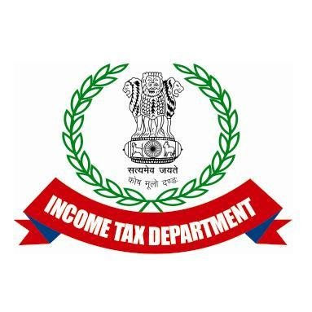

GROUP: 15

**Student Declaration**

This is to declare that this report has been written by me/us. No part of the report is copied from other sources. All information included from other sources have been duly acknowledged. I/We aver that if any part of the report is found to be copied, I/we are shall take full responsibility for it.

Aditya suryavanshi

Roll no:- K19KBB43

Paramveer singh Sisodiya

Roll no:- K19KBB44

Deepak Garg

Roll no:- K19KBB45

Place -

BONAFIDE CERTIFICATE

Certified that this project report “INCOME TAX DEPARTMENT OF

INDIA” is the bonafide work of “PARAMVEER SINGH SISODIYA,

ADITYA SURYAVANSHI AND DEEPAK GARG” who carried out the project work under

my supervision.

<<Signature of the Supervisor>>

<<Name of supervisor>>

<<Academic Designation>>

<<ID of Supervisor>>

<<Department of Supervisor>>

Introduction:

The Income Tax Department is governed by the Central Board for Direct Taxes

CBDT) and is part of the Department of Revenue under the Ministry of

Finance.  The Income Tax Department (also referred to as IT Department or ITD)_

is governments_Agency undertaking direct tax collection of the Government of

India. Main responsibility of IT Department is to enforce various direct tax laws.

Taxation has been one of the key function of sovereign state feom the ancient

times. In manusmriti the manu, started the king has the sovereign power to levy

and collect the tax according to sastras.

*लोके च करादिग्रहणो शास्त्रनिष्ठः स्यात् ।*  manu sloka

 Income was classified under four schedules:

i) Income from landed property

ii) Income from professions and trade

iii) Income from securities, annuities and dividends

iv) Income from salaries and pensions. Agricultural income was subject to Tax

Consequently, many laws were brought to streamline income tax laws. For

Example, Super-Rich Tax was introduced in 1918 and new Income-Tax Act was

Agreed in 1918. But most important among all these were The Income-tax Act of

1922. This Act of 1922 marked an important Change from the Act of 1918 by

Ever-changing the administration of the Income tax from the hands of provincial

Govt. to the central govt. Another Remarkable feature of this Act was that the

Rales were to be enunciated By the annual final acts instead of in the basic

Enactment. Again, new Income-tax Act came in 1939.

just like in any other organisation, employee performance of Indonesia’s taxation

unit is influenced by established standards, which determine the quality of work,

Completion of targets and of course instilling responsibility in employees who are

Required to demonstrate such values through the implementation of the

Predetermined work procedures and policies. This study is a survey which uses

a descriptive method. The descriptive method involves the assessment of

research variables, which aims to determine the relationship between such

variables and their influence on the findings of the study.

In summary, based on data processing results, worker compensation and

one’s

competence were of the same coefficient value, compared with the work

discipline aspect or variable. In this regard, it is therefore interpreted as:

1 Work discipline as a variable has a certain degree of contribution to

motivation. This means that workers, with good discipline at work,contribute to

individual motivation. This may also influence the compensation received by

employees from their employer.

2 There is a contribution from the competence variable to work motivation of

the employees. This means that competence variable contributes to work

motivation of an employee within an organisation.

3 However, there are other factors which influence work performance besides

the mentioned variables.

DESCRIPTION OF PROJECT

We use the html css and java script for making the project about income tax

department of india.here is some modules and prepare pictorial flow of project.

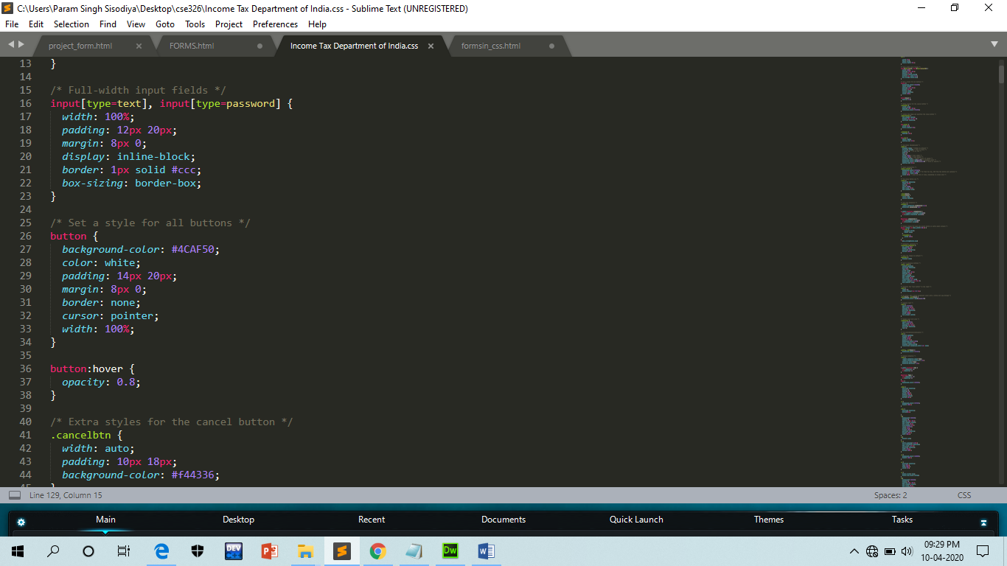

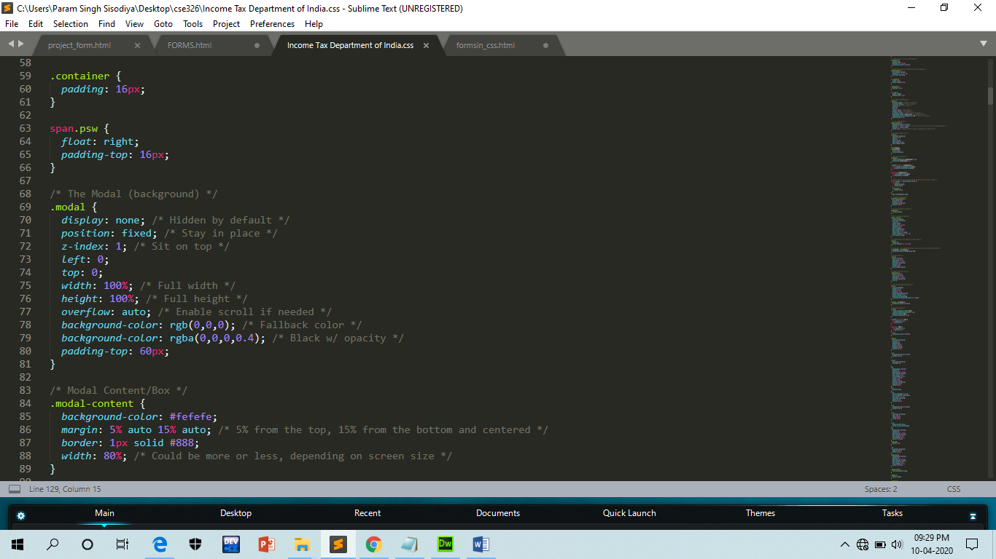

Home Page:

Users can get details related to the department, its organisational setup,

functions, tax law and rules, etc. Information about PAN, TDS, tax information

network, tax payers, etc. is given. It would show the login credentials. It would

also have a forgot password link. It would contain several tabs like feedback,

contact us, Quick links, etc. It would showcase the logo, important news and

latest updates.

Login, create a new account and forgot password:

Existing users can login by entering their user name and password. New users

can create their account. The users need to enter their valid details in the

respective fields and in case user forgot their password then they can also create

new password by clicking on the forgot password button.

About Us, Contact us and Feedback:

Users can know about the history, authorities, vision mission and values in About

Us page. By contact us page user can contact the officials if they face any

problem and by feedback page users can also give feedbacks to improve and

how to make this website more user-friendly.

Quick Links, FAQ’s, News and updates and Accessibility:

Users can go to quick links to save time and they can also go to FAQ’s section If

they have any questions or any issue. Users will get every news and updates

related to taxes and other stuffs. Also, user can change the text size, text font

and other things according to their needs and convenience.

Module - Wise Work Distribution:

|  |  |
| --- | --- |
| Aditya Suryavanshi | Overall home page, Contact Us, Login and Forgot password. |
| Paramveer Singh Sisodiya | About Us, Accessibility, Quick links. |
| Deepak Garg | News and updates, FAQ’s and feedback. |

LOGIN

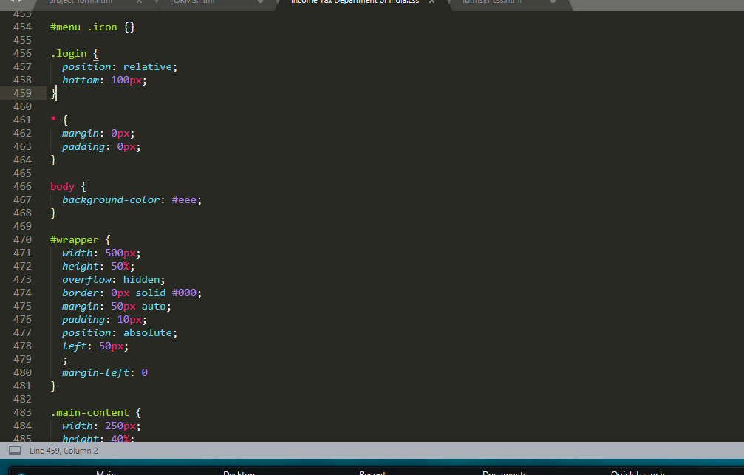

FORGOT PASSWORD



LINK

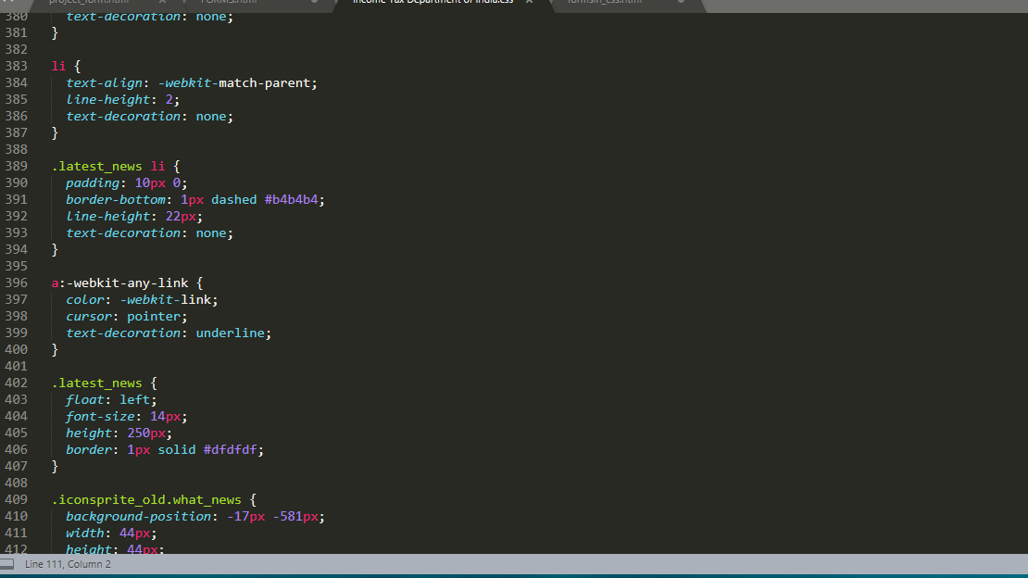

News and update

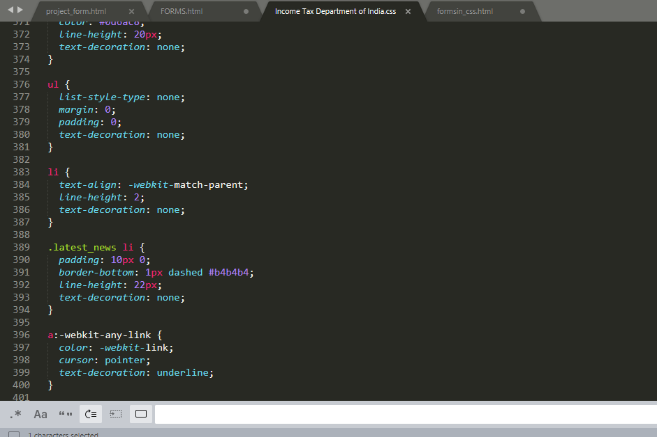

overview:

Our site would provide the complete information about the Tax information

Network of Income Tax Department of India. Users can get details related to

the department, its organisational setup, functions, tax law and rules, etc.

Information about PAN, TDS. Users can access online services such as

Instant E- Pan, Link Aadhar, Submit forms and ITR status. User can also

Check the latest news and updates.

Frequently Asked Questions and Answers relate to Permanent Account

Number (PAN) are provided by the Income Tax Department. You can find

questions and answers on what is PAN, why is it necessary to have PAN,

where to apply for PAN? etc. Information about the documents relevant to

apply for PAN and authorities etc. is also provided. Related links are also

available.

The users would also be able to give their feedbacks and can contact the

officials through the contact us and feedback section.



SWOT Analysis:

Strength:

The project will help the users in many ways as they can do their tasks just by

sitting in their homes at the click of a button. This will also decrease the paper

work and their document will be safe.

Weakness:

Many people do not consider doing their work online. They think that doing work

online is not safe so we have to make people believe that this the safest option

for filling their taxes and doing other works.

Opportunities:

Website enables many interactive features to help the users to interact with the

host and know more about the features of this online platform.

Threats:

Increasing competition among the websites and enabling more interactive

sections is a threat towards the versatility and functioning of the website.

our web page

